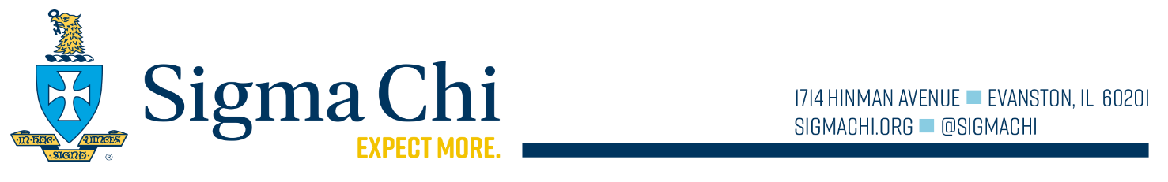
International Balfour Award Application

Each year, the Fraternity recognizes its most outstanding seniors with Balfour Awards. Now is the time to honor the senior in your chapter who has dedicated himself to the Fraternity, campus, and community. Make sure you take this chance to pay tribute to this worthy brother. Only Province Balfour Award winners are eligible to apply for the International Balfour Award.

If you are selected as the Province Winner...
You need to email a completed application packet to the General Fraternity Headquarters at awards@sigmachi.org by April 15, 2021. All letters of recommendation should be addressed to the Balfour Award Selection Committee. Please follow the format below when completing your brochure.

Province Winner International Balfour Award Brochure
Page Number | Item
Cover | International Balfour Award; professional headshot, name of candidate; university; chapter name; province name.
1 | Cover letter from candidate explaining his background and most distinguishing accomplishment or character trait.
2 | Academic transcript, including the most recently completed term. Be sure the transcript includes a cumulative grade point average. Multi-page transcripts may be included.
3,4,5 | A maximum of three pages should be devoted to outlining Fraternity, campus, and community involvement and employment, including positions held and honors received.
6 | Letter of recommendation from the university president, vice president, dean or other high ranking administration official that you have a personal relationship with
7 | Letter of recommendation from the Grand Praetor.
8 | Letter of recommendation from the chapter advisor.
9, 10 | Other letters of recommendation. These letters could be from the faculty advisor, greek advisor, a professor, or supervisor at work.

These packets will be reviewed by the Balfour Award selection committee, which will determine the finalists. These individuals will be contacted and asked to attend the 2021 Krach Transformational Leadership Workshop (from Friday July 30 through Sunday August 1) where the International Balfour Award winner will be announced.

Email Packet to: awards@sigmachi.org

If you have any questions about the award or application process, please contact Headquarters at (847) 425-4443.

