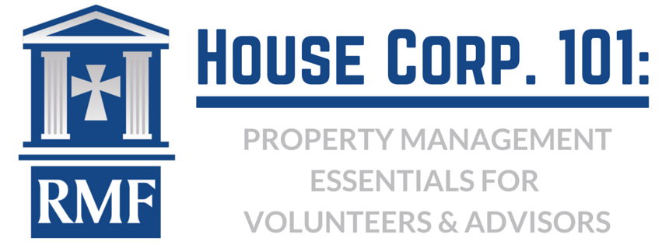

House Corp Professional Service Agreements Recommendation:

Life Safety:
- Fire Alarm System Monitoring: annual contract; emergency contact information should be updated semi-annually
- Fire Alarm System Inspection & Annual Certification: annual contract for inspection and certification of FACP panels and smoke detectors
- Fire Extinguishers Inspection & Annual Certification: annual contract for inspection and certification of extinguishers and retagging
- Life Safety Systems Inspection & Annual Certification: annual contract for inspection and certification:
- Electrician: all Emergency backup lights, emergency circuit lights horns & strobes and exit door lights; all panels; all outlets and light switches with cover plates
- Door or General Contractor: all exit doors & panic hardware, all smoke doors & closers, all 1-hour rated doors (incl bedrooms) and closers
- Ceiling or General Contractor: all fire rated ceilings including drop acoustical
- General Contractor: all stair handrails & treads, emergency exit stairs, balcony porch and deck railings; bedroom emergency window exits for operation & accessibility, no illegal bed lofts
- Kitchen Hood & Fire Suppression System (if applicable) Inspection & Annual Certification: annual contract for inspection and certification; cleaning hood & filters and exhaust system including roof or wall outlet, tagging fire suppression system
- Kitchen Equipment (if applicable): annual contract for inspection including gas connections and professional cleaning and shutting down for summer. Service agreement for repairs as needed
- Fire Sprinkler System (if applicable): Inspection & Annual Certification: annual contract for inspection and certification
- Laundry (if applicable): annual contract for semi-annual inspection of water supply and drain hoses and dryer exhaust vent and cleaning of lint in exhaust hose
Preventative Maintenance: annual contract for inspection and certification and service agreement for repairs as needed:
- HVAC: Bi-monthly inspection and servicing of units including filter changes
- Plumbing: annual inspection of all hot water heaters, fixtures, drains and hose bibs for operation, leaks and proper drainage/clogs.
- Roofing; annual inspection of roof surfaces for deterioration and leaks, all vent penetrations and flashings; soffit & Fascia for deterioration/rot
- Gutters & Downspouts: clearing of seasonal leaves & debris; inspection of grade, pitch, flow & leaks and all connections and on grade drainage
- Electrical: annual inspection of all exterior and security lighting, exterior outlets weather protected re-lamping of interior ceiling fixtures with proper bulbs
- Pest Control: quarterly inspection and service (rodents, insects, termites, etc.)

